Country Facts Form
Formal Name | 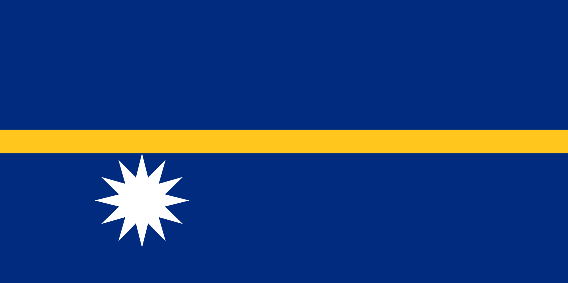  Nauru
Short Name | NRU
Capital | Yaren
Major Cities | Nation Capital Region-Yaren

Geography
Climate | Tropical, Rainy Season (November to February)
Natural Resources | Phosphates, Fish.
Time Zone | UTC +12h
Total Area | 21 sq km, (8 sq miles) | Natural Hazards |  | Rising sea level

People
Population | (2015 est.) 10.500 | Official Language |  | Nauruan
Life Expectancy | 66.4 For both sexes (2014 est.)  Male: 62.3  Female: 69.83 | National Day |  | 31stJanuary 1968(Independence Day)
Ethnic Groups | Nauruan, I-Kiribati, Tuvaluan, Fijian,
Religion | Christian (two-thirds Protestant, One-Third Roman Catholic.

Government
Government Type | Republican Presidential. | President/  King |  | Hon. Baron Waqa
Legal System | Legislative and judicial branches of Government

Economy
GDP (purchasing power parity) |  | GDP - PER CAPITA (PPP)
Exchange Rate (to USD) |  | Unemployment rate
Imports | Meat, Pork, Chicken, Milk, Rice, Flower, Fruits, Vegetables.
Exports | Phosphate, Rocks and Coconut Products.

